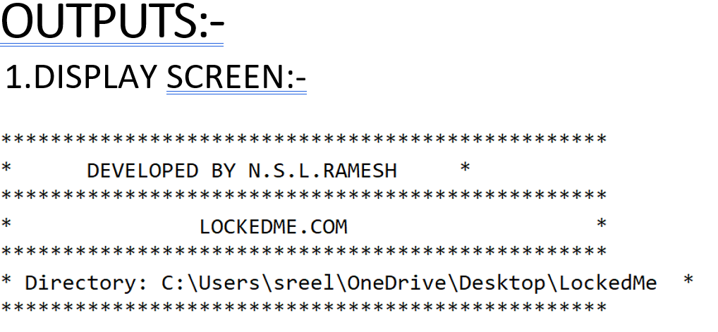

2.Listing All Files In The Directory :-

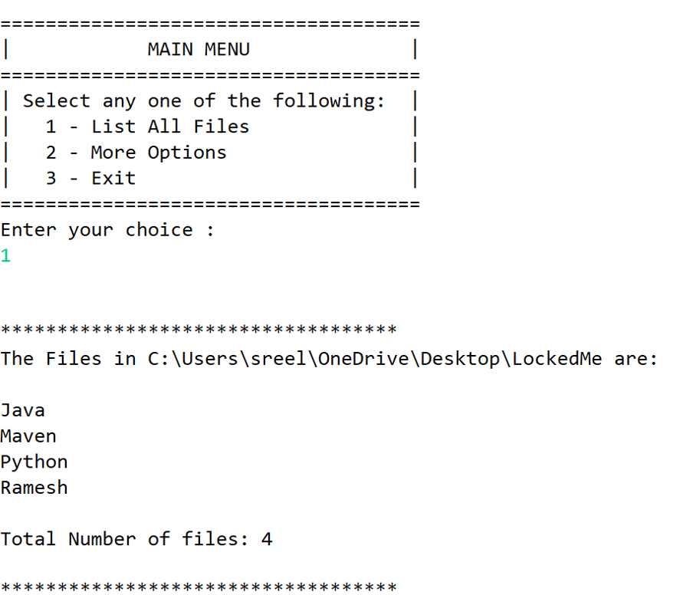

3.Adding Files To The Existing Depository:-

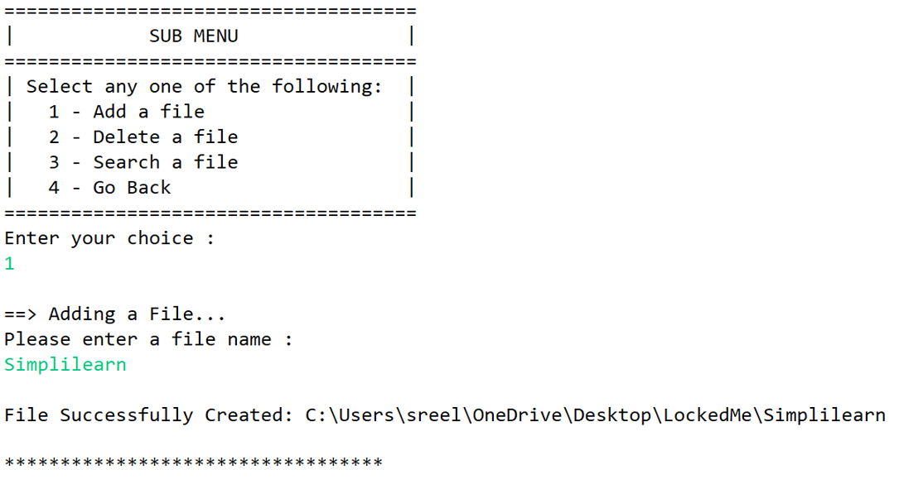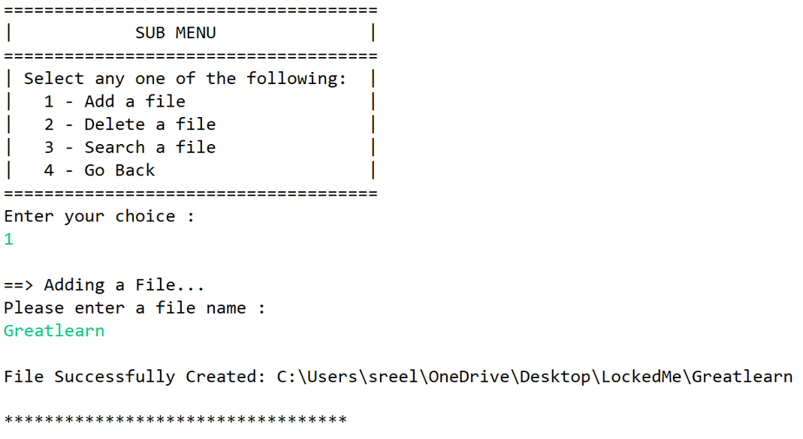

4.Deleting A File In The Depository:-

4.1:-Deleting A File If Found :-

4.2:- Displaying A Message If Not Found:-

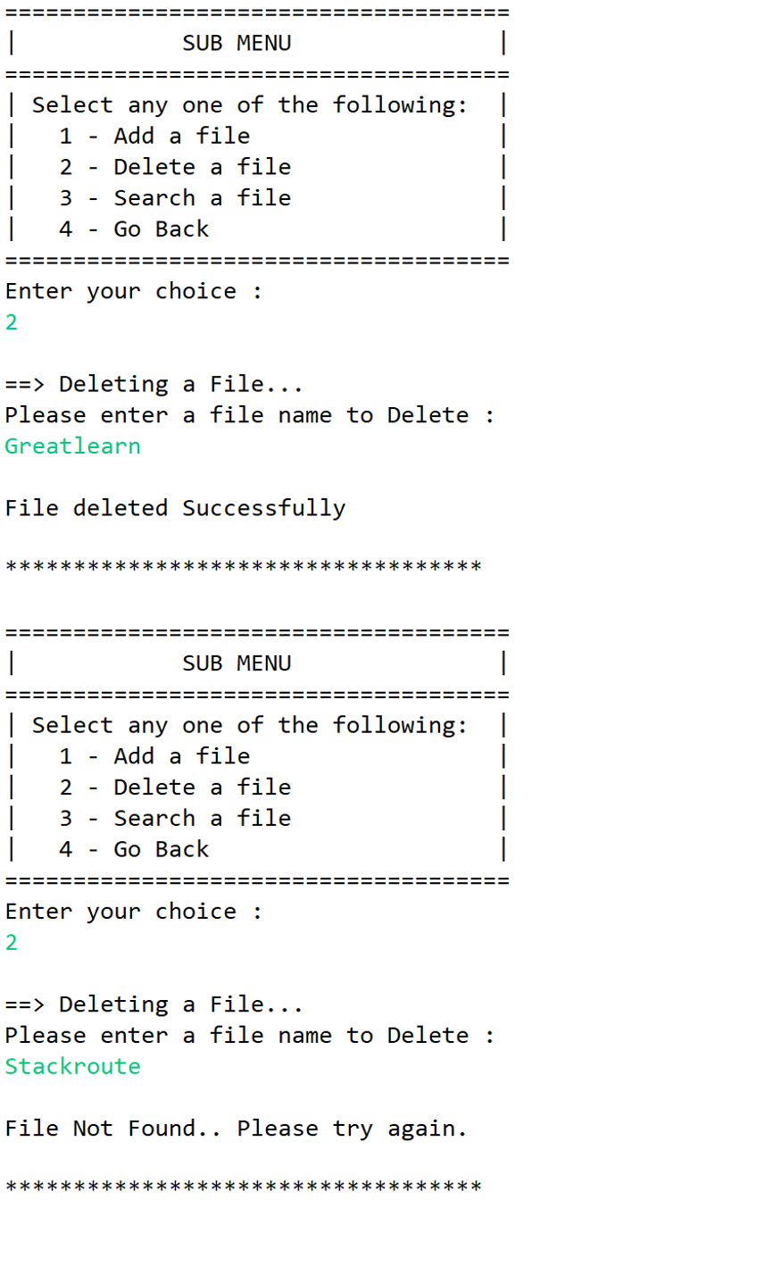

5.Searching A File If Found:-

5.1:- Searching A File If Found :-

5.2:- Displaying A Message If Not Found:-

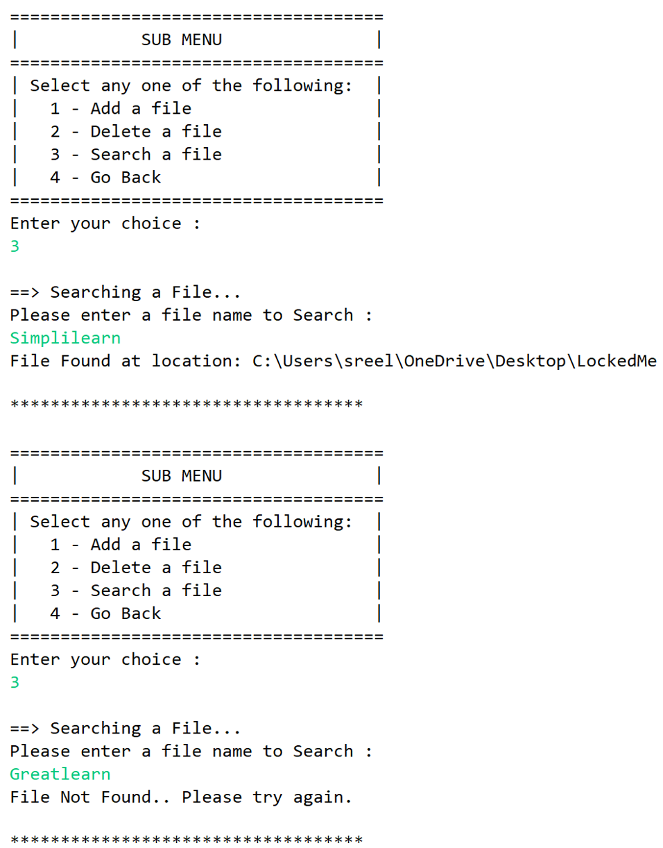

6.Sorting All The Files In Assending Order:-

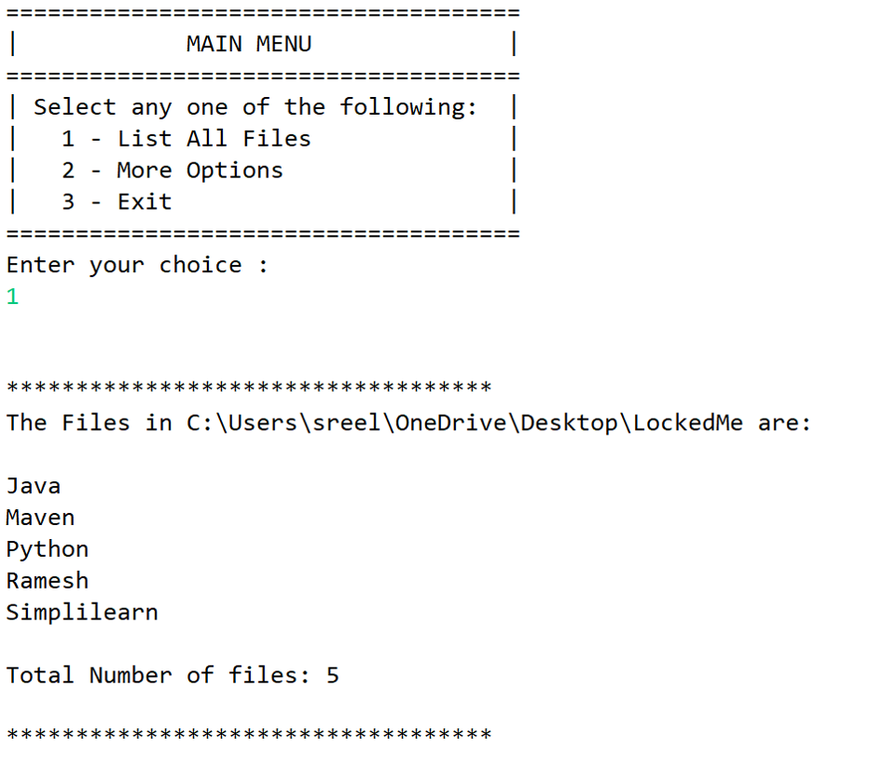

7.Exiting The Program:-

